
Volume 3 Number 6 June 2024
E-ISSN: 2963-2900 | P-ISSN: 2964-9048
https://jmi.rivierapublishing.id/index.php/rp

Threats and Opportunities For Textile and Other Textile Products (TPT) in The Efta Market Using The Indonesia-Efta Scheme

Kayla Putri Arvina
Fakultas Ekonomi Dan Bisnis, Universitas Padjadjaran, Jatinangor
Email: arvinakayla@gmail.com

Abstract
This thesis examines the problems and opportunities faced by the Indonesian textile and textile products (TPT) industry in the European Free Trade Association (EFTA) market through implementing the Indonesia-EFTA scheme. The analysis tool used is Revealed Comparative Advantage (RCA), which allows the detection of relative comparative advantages in Indonesia's textile exports to the EFTA market. The report highlights various important aspects that affect Indonesia's textile competitiveness in the market, including trade rules, quality requirements, and consumer trends. The results of the RCA analysis provide in-depth insight into the relative position of Indonesian TPT in the EFTA market, as well as the potential for sector development in the context of the Indonesia-EFTA trade agreement. These findings can provide a framework for government policies and business strategies for textile industry players to take advantage of opportunities and address challenges in strengthening their competitiveness in the EFTA market.

Keywords: Challenges, Opportunities, Textiles, Textile Products, EFTA, Indonesia-EFTA, Revealed Comparative Advantage (RCA).

Corresponding Author: Kayla Putri Arvina

E-mail: arvinakayla@gmail.com

INTRODUCTION
Background
International trade refers to exchanging goods and services between countries, involving exports (goods sent to other countries) and imports (products received from other countries). The main goal of international trade is to improve a nation's standard of living by encouraging economic growth, creating job opportunities, supporting the industrial sector, and attracting international corporate investment. Nevertheless, when participating in global trade, countries inevitably face obstacles that often result in an inability to achieve the benefits of international trade.
Today, international trade is generally characterized by a preference for free trade, usually facilitated through bilateral or multilateral cooperation. Agreements are often formed with the primary purpose of ensuring that all obstacles are then removed for the parties involved. A country's trade operations directly impact the rate of global economic growth. The wider a country's trade activities, the faster the global economic growth.
To boost Indonesia's international trade between 2019 and 2024, the country is prioritizing four key areas: strengthening economic diplomacy, protecting national interests through diplomacy, asserting sovereignty and national interests through diplomacy, and enhancing Indonesia's influence and leadership in the global and regional arenas. In addition, there is a special focus on infrastructure improvements and diplomatic efforts. Indonesia's main focus in its foreign policy is economic diplomacy, actively contributing to national economic growth and development.
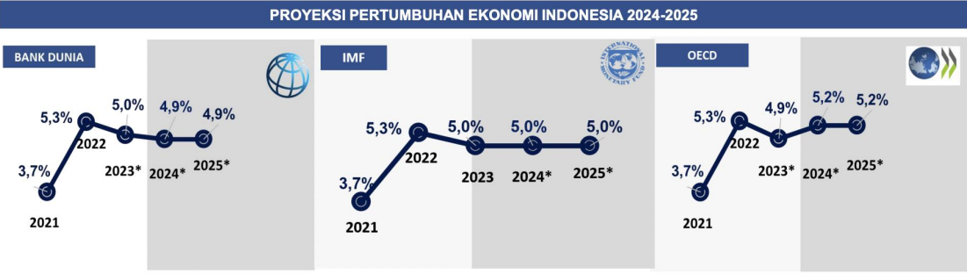
The graph below illustrates Indonesia's significant economic growth in 2024, with considerable increases observed from 2021 to 2022. Indonesia's economic development showed a downward trend in 2022 but stabilized in 2023 and 2024. Thanks to the stability observed in 2023 and 2024, Indonesia's economic development is expected to remain stable until 2025.

Figure 1. 1 Indonesia's Economic Growth Projections 2024-2025

Source: IMF (January 2024), World Bank (January 2024), and OECD (November 2023)

The IE-CEPA EFTA agreement has helped the textile industry, which is believed to have promising market prospects, even though competition is fierce between ASEAN countries and the world.
Based on the previous description of the impact of the growth of the Textile and Textile Products Industry in Indonesia, the research was conducted under the title "Challenges and Opportunities of Textiles and Textile Products (TPT) in the EFTA Market Using the Indonesia-EFTA Scheme."
Problem Formulation
1. What are the challenges of textiles and other textile products (TPT) in West Java in exporting to the markets of EFTA member countries?
2. What are the opportunities for West Java textiles and other textile products (TPT) to export in the EFTA Market?
Purpose of the Problem
1. To find out the challenges of textiles and other textile products (TPT) in West Java in exporting to the markets of EFTA member countries.
2. To analyze the opportunities for West Java textiles and other textile products (TPT) to export in the EFTA Market.
Research Benefits
This research is needed to make a useful contribution to scientific development and practical needs. The benefits of the research can be described as follows:
1. Business actors or exporters of textiles and other textile products (TPT) in West Java
as a source of information and media that can be a reference for increasing the productivity of Indonesian textile exports to EFTA countries.
2. Colleges and Students
This research is expected to clarify the policy of the Indonesia-EFTA free trade agreement the comprehensive economic partnership agreement between Indonesia and EFTA, and can also be used for further research.
3. Government
This research is expected to be one of the fundamental aspects in business political decisions towards the textile industry to increase the sector's productivity in Indonesia.
4. Community
This research is expected to expand a more comprehensive understanding and provide information that can be used to understand the export trade of the textile sector after the establishment of the Indonesian European Comprehensive Economic Partnership Agreement (IE-CEPA).

RESEARCH METHODOLOGY
The author uses a descriptive and qualitative approach to explain current issues in this section. This study aims to obtain descriptive data by analyzing data from several sources, including primary and secondary sources. Data sources include documents, media coverage, views from stakeholders involved in international trade agreements, as well as previous research related to free trade agreements between Indonesia and Europe within the Indonesia-EFTA framework and their impact on the agricultural sector in Indonesia.
Type of Research
The research methodology used in this thesis is a qualitative case study. A case study is a research approach that collects and analyzes data related to a specific event or situation (Hardani et al., 2020). The main objective of the qualitative approach in this study is to obtain a thorough understanding of various phenomena, including behaviors, perceptions, motivations, and activities observed in the research subjects. The data produced is qualitative and expressed in words rather than numbers. Qualitative research provides benefits, especially theoretically, that contribute to the advancement of knowledge. However, the study also has practical significance for problem-solving purposes. The main methods used to collect data are triangulation and inductive/qualitative data analysis, focusing on relevance rather than generalization.
Research Location
The research site is where researchers make observations to collect relevant data in the research context. The researcher has chosen West Java Province as the research area and the Bandung Free Trade Agreement Center as the institution that is the focus of the research. The selection of West Java Province is based on its potential as a producer of popular textile commodities spread across various regions in the province. In addition, West Java Province is also known as a consultation area for export and import activities in Indonesia, which is generally identified as the Free Trade Agreement Center Bandung.

Research Time
Table 1. Research Time Plan

Activity Stages | Research Time
Moon | November | December | January | February | March | April
Sunday | 1-4 | 1-4 | 1-4 | 1-4 | 1-4 | 1-4

Determining the Research Topic

Initial Data Collection

Creating Research Methods

Research Proposal Seminar

Research

Preparation of Final Project Report

Exam Session

Data Collection Techniques
Various data collection strategies were used in qualitative descriptive studies to understand the implementation of IE-CEPA EFTA in the textile sector. The textile business is faced with regulatory issues due to the formulation of the current problem. This can be solved by using methods such as observation, documentation, and literature review. The analysis of the comparative advantages revealed focuses on potential opportunities for the textile industry in countries that are members of the European Free Trade Association (EFTA). By integrating these three methodologies, the study can generate extensive data to assist in analyzing the application of IE-CEPA EFTA in the textile industry.
Data Analysis Techniques
This study uses qualitative analysis as a data analysis technique, especially using Sugiyono's theory, which is described in the book "Qualitative Research Methods" published in 2014. Regarding the implementation of the declaration of origin of goods and preferential tariffs in the IE-CEPA agreement, as well as the utilization of the IE-CEPA trade agreement by the textile industry in West Java, the data analysis process will include similar steps in collecting, subtracting, presenting, and drawing conclusions from relevant data. The main focus of this analysis will be on the implications of trade policies for the textile industry in West Java and its access to the EFTA market, as determined by the researchers. Therefore, the necessary data analysis methodology includes several stages.

RESULTS AND DISCUSSION
Analysis of West Java TPT Opportunities in the EFTA Market
Description of Opportunity Data Analysis Techniques
The data analysis technique used is Revealed Comparative Advantage (RCA). The World Bank said that this technique is an analytical technique used to measure the value of a country's export potential. This method is based on relative export share, whe ratio between the export value of a country's products and those worldwide. The RCA indicates whether a country is expanding products with trade potential, compared to a situation where the number of products that can be exported competitively is static. Countries with similar RCA profiles will likely not have high bilateral trade intensity unless it involves intra-industry trade. This research usually uses export, import, and production data, which are absorbed from secondary data sources such as UN Comtrade, World Development Indicators, and Regulation of the Minister of Finance. To calculate RCA, the equation is used:

$$RCA=\frac{\frac{Xij}{Xit}}{\frac{Xnj}{Xnt}}=\frac{\frac{Xij}{Xnj}}{\frac{Xit}{Xnt}}$$
Information:
Where x represents exports, i represents countries, f is a commodity, t is a set of commodities, and n is a group of countries
- Xij = Commodity exports of a country j
- Xit = Export of all goods of a country t
- Xnj = World commodity exports j
- Xnt = Export of all the world's goods

The product or country competes strongly in the international market if the RCA is more than one (> 1). The competitive advantage is weak if the RCA number is less than one (< 1).

Data Analysis
West Java Trade Balance

Table 2. West Java Trade Balance (in US$ Million) for the 2019-2023 Period

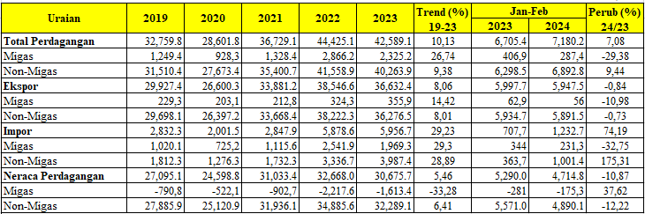
Source: Central Statistics Agency, by the Data and Information Systems Center of the Ministry of Trade
The development of West Java's trade balance can be seen in the table above, and it is stated that the non-oil and gas sector is a considerable contributor compared to the oil and gas sector. West Java's trade value peaked in 2022, with a total trade of US$ 44,425,100. However, there was a decline from 2022 to 2023, with a total trade of US$ 1,836,000. Despite the decline, the total development of non-oil and gas trade in West Java has increased since the pandemic. With quite rapid growth, it can be seen that the quantity of non-oil and gas trade has also increased.
Indonesia's Trade Balance to EFTA Countries
With the selection of the Indonesia-EFTA Comprehensive Economic Partnership Agreement, the opportunities for partner countries to be analyzed are Switzerland, Iceland, Norway, and Liechtenstein. The following is the Indonesia-EFTA state trade balance:

Table 3. Indonesia-EFTA Trade Balance
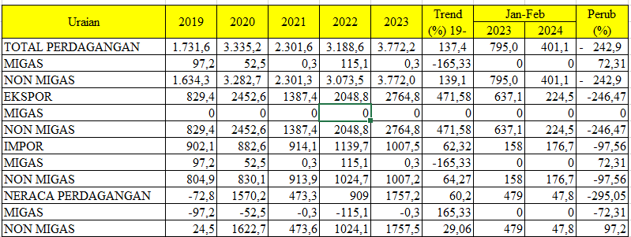
Source: Central Statistics Agency, processed by the Data Center and Information Systems of the Ministry of Trade

The non-oil and gas sector plays a bigger role than oil and gas, both in terms of exports and imports. It comprises agricultural exports, processing industries, manufacturing products, and textiles.
Export-Import of Textiles and Other Textile Products (TPT) in West Java

Table 4. TPT Exports in West Java

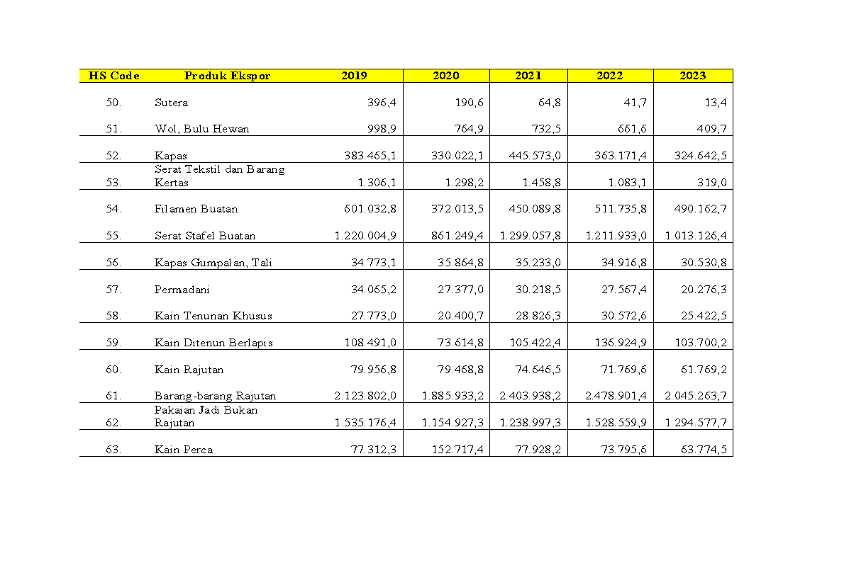
Source: Central Statistics Agency of West Java
The development of textile and other textile product exports (TPT) in West Java is very diverse. Starting from HS CODE 50 with silk to HS CODE 63 with patchwork. The table above shows that HS CODE 61 with knitted goods continues to hold the highest position from 2019-2023. Usually, knitted goods are exported to countries with winter continents, such as Europe, North America, South America, and even Australia. Followed by HS CODE 62 with non-knitted apparel. The Ministry of Trade said that the destination countries for apparel exports from Indonesia from 2018-2023 are the United States, Europe, Japan, Germany, and South Korea. This trend will continue in 2023, when the value of apparel exports to the United States will reach USD 1.07 billion or 53.48% of total apparel exports from Indonesia. In the January-March 2023, Central Java and West Java are Indonesia's main apparel exporting provinces. Apparel exports from West Java reached USD 784.15 million, or around 39.14% of Indonesia's total apparel exports.

Indonesian exports to EFTA

Table 5. Indonesia's Exports to EFTA

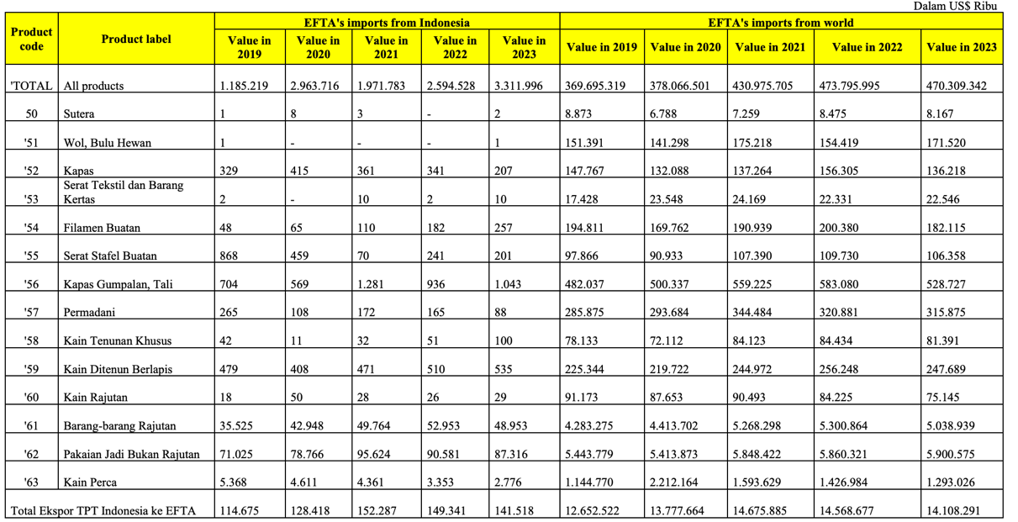
Source: ITC calculations based on UN COMTRADE and ITC statistics
The IE-CEPA agreement is Indonesia's first trade agreement with countries on the European continent. In the textile and other textile products (TPT) association, it can be seen that HS CODE 61 and 62 with knitted goods and non-knitted apparel occupy the highest position with the highest export value in 2021 with a total value of US$ 95,624 out of a total export of 1,971,783. However, the highest value of Indonesia's textile exports to EFTA is in 2023, totaling US$ 3,311,996. In that year, non-knitted apparel exports decreased, but textile exports with other HS CODES also increased. Thus, the total export value of textile products from Indonesia to EFTA is the highest in 2023.

Import Indonesia to EFTA

Table 6. Import Indonesia to EFTA

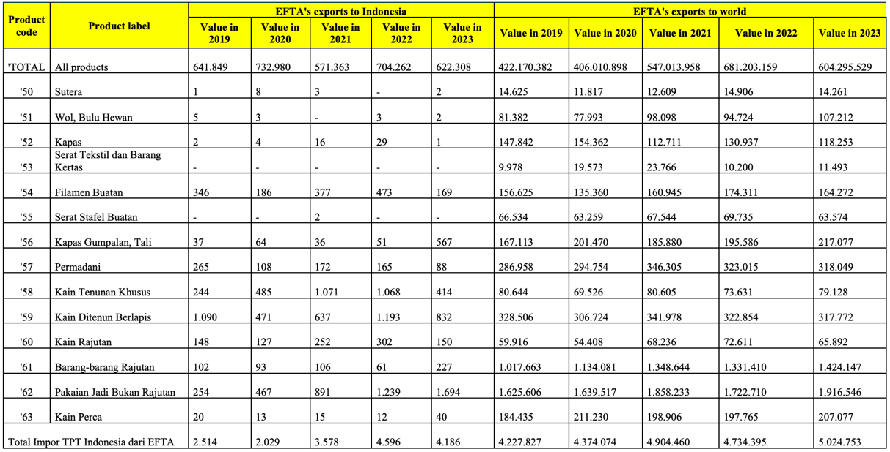
Source: ITC calculations based on UN COMTRADE and ITC statistics

In addition to exports, Indonesian textile products are also imported from countries in EFTA. Table 24 says that HS CODE 59, which is coated woven fabric, is the most imported good from EFTA countries to Indonesia. In addition, the highest value of Indonesia's imports from EFTA was in 2020, with a total of US$732,980. Meanwhile, the lowest import value was last year, namely 2023, with a total import value of US$622,308.

Indonesia's Textile and Other Textile Products (TPT) Exports to the World

Table 7. Indonesia's TPT Exports to the World

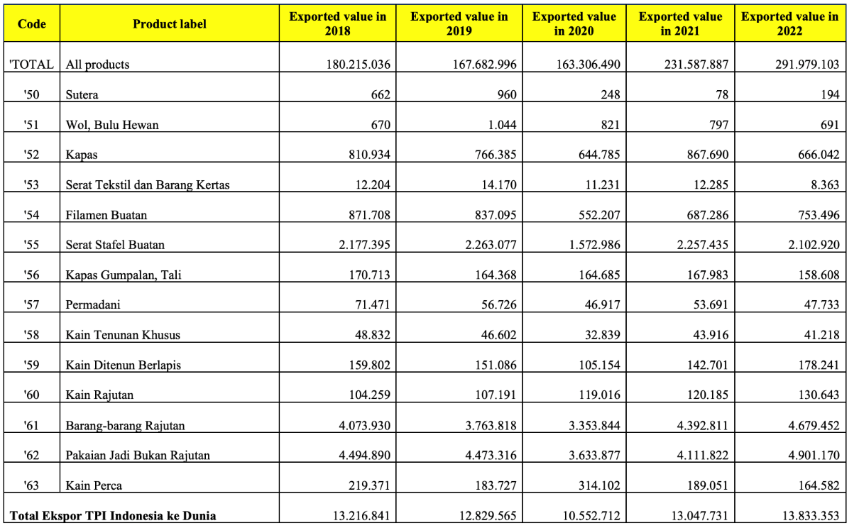

Source: ITC calculations based on UN COMTRADE and ITC statistics

Like textile exports to EFTA countries, Indonesia's highest textile exports worldwide are also occupied by HS CODE 61 and HS CODE 62. The total value of all TPT products (HS code 50-63) was US$291,979,103 in 2022. In the table above, the highest export value of products is occupied by HS CODE 62, with non-knitted apparel of US$4,901,170.

World Exports to the World

Table 8. World Exports to the World

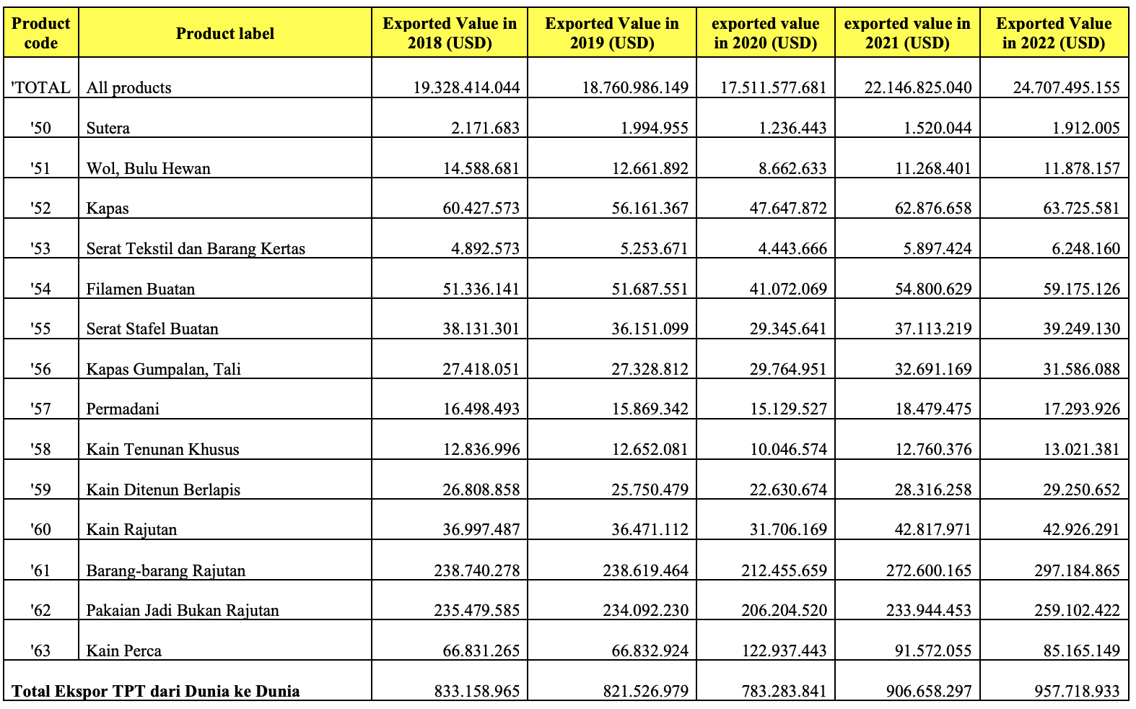

Source: ITC calculations based on UN COMTRADE and ITC statistics

Of course, exports from the world to the world have a much higher export value than Indonesia's exports to the world. When viewed from the "all products" line, it can be concluded that textile product exports continue to increase from 2018 to 2022. Of course, this is a good sign for textile exporters. TPT business actors can see good opportunities with a significant trend increase from year to year. This is a great opportunity to export TPT in even larger quantities.

Indonesian Imports from the World

Table 9. Indonesian Imports from the World

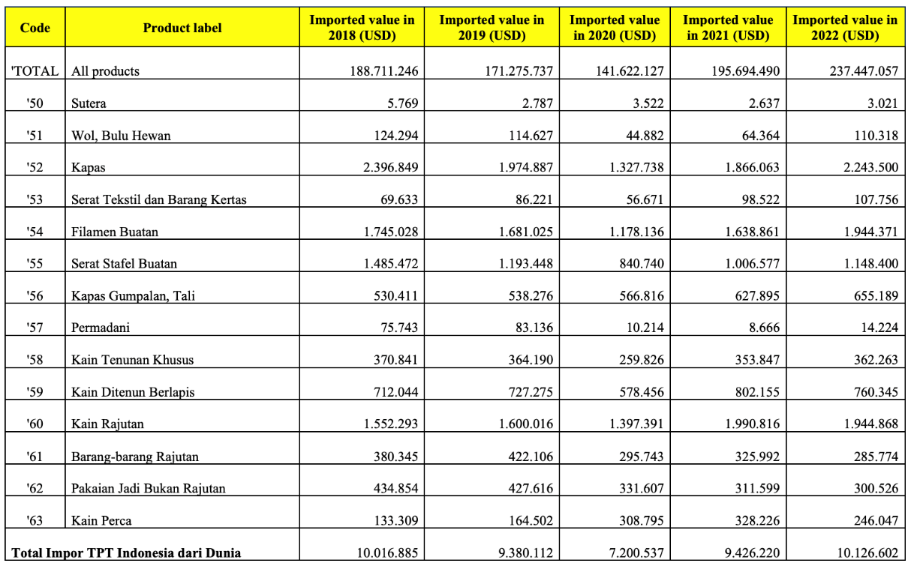

Source: ITC calculations based on UN COMTRADE and ITC statistics

Similar to imports from EFTA countries, Indonesia also carries out import activities from other countries. For textile products, in 2022, Indonesia made the highest Export in HS CODE 52, namely cotton products, with a total import value of US$2,243,500. The lowest import in HS CODE 51 was animal hair, which was US$3,021.

World Imports from the World

Table 10. World Imports from the World

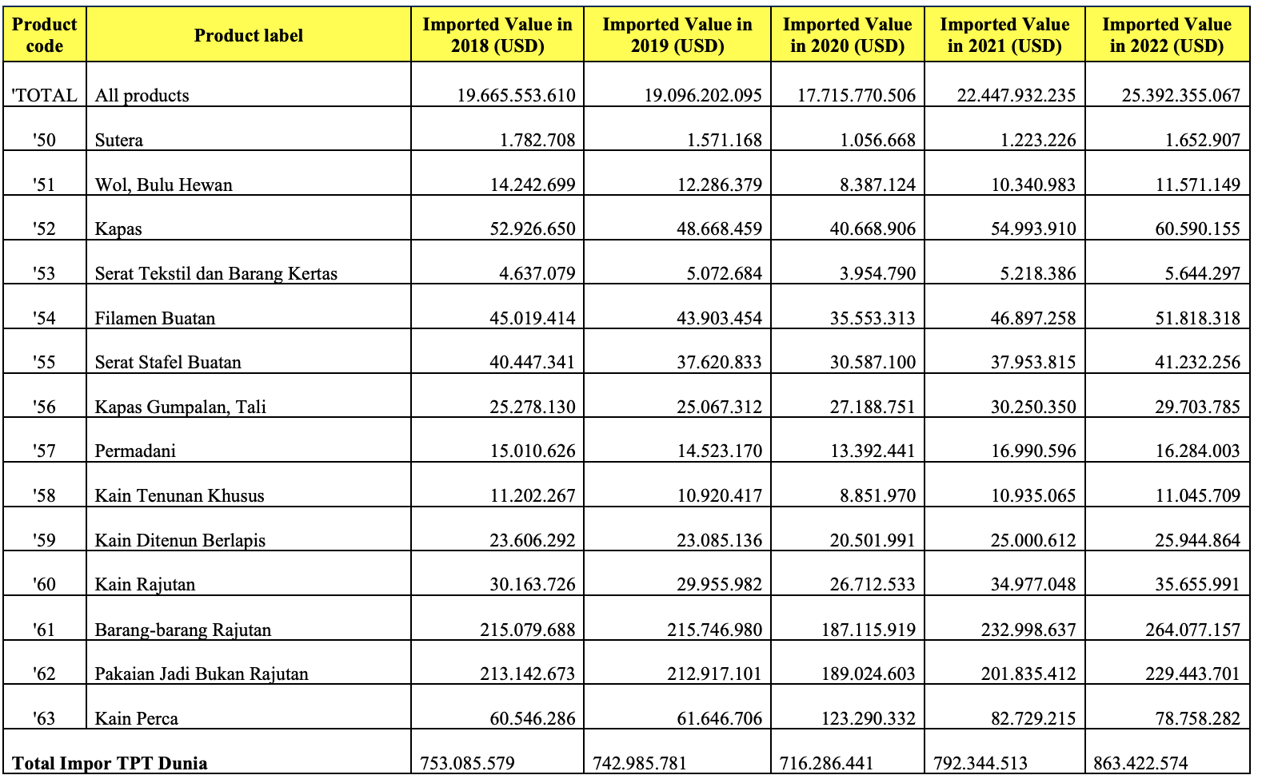

Source: ITC calculations based on UN COMTRADE and ITC statistics

Table 28 shows data on world textile and other textile products (TPT) imports. Imports of textile products have always increased from 2018 to 2022. In 2022, the TPT products that carry out the most import activities are in HS CODE 61, with knitted goods amounting to US$264,077,157.
Analysis of Research Results
RCA ANALYSIS
Revealed Comparative Advantage (Indonesia), 2020, 2021, 2022

Table 11. Revealed Comparative Advantage (Indonesia), 2020, 2021, 2022

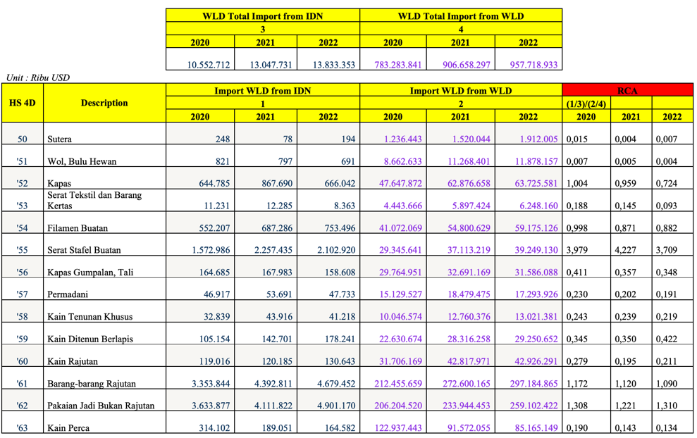

The data set collected and analyzed using the revealed comparative advantage (RCA) method provides information that in 2022, Indonesian products with the highest export competitiveness to EFTA countries are HS CODE 55, namely Artificial Stafel Fiber with a score of 3,709. This product is highly competitive due to the low import value from Indonesia to the world for these products. In 2021, this product has soaring competitiveness with an RCA value of 4.22. The RCA value shows that artificial staple fiber products have above-average comparative competitiveness compared to other products. This is due to the large demand for imports worldwide compared to the total imports of all textile products. From the results of the calculation using the revealed comparative advantage method, it can be seen that textile products in West Java province in 2020-2022 have weak competitiveness or < 1 and strong competitiveness > 1 as follows:

Table 12. Competitiveness of West Java TPT Products Worldwide

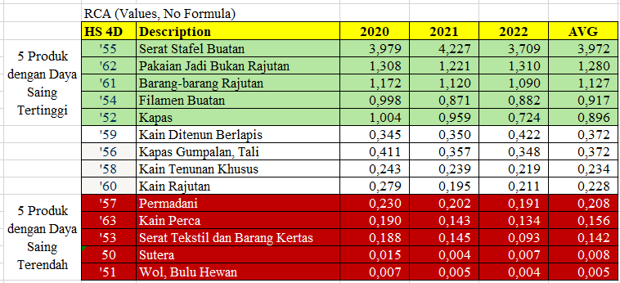

With an RCA value of more than 1, it can be concluded that West Java textile products are highly competitive worldwide, such as HS CODE 55, the name of artificial staple fiber products. Meanwhile, the products with the lowest competitiveness are wool animal hair with HS CODE 51.

Bilateral Revealed Comparative Advantage (Indonesia), 2020, 2021, 2022

Table 13. 14 Bilateral Revealed Comparative Advantage (Indonesia), 2020, 2021, 2022
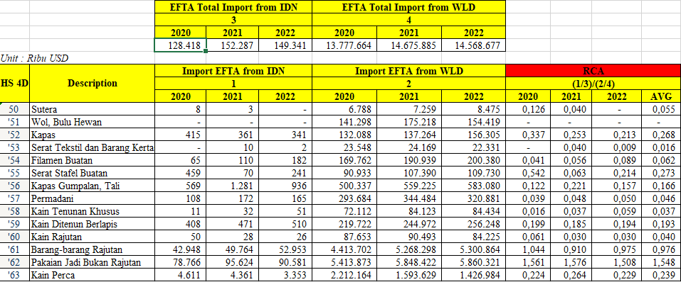

Table 4.20 shows the analysis of the competitiveness of West Java TPT products in EFTA. The highest average is owned by HS CODE 62 with non-knitted apparel. From the existing data, it is analyzed and re-concluded which products have high and low competitiveness, as shown in the table below.

Table 14. 15 Competitiveness of West Java TPT Products in EFTA Countries (2020-2022)

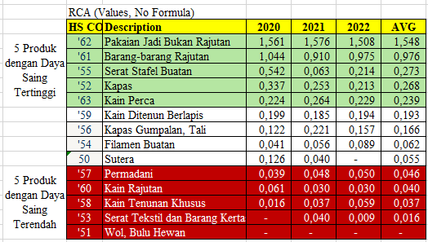

From the results of the Bilateral Revealed Comparative Advantage (BRCA) calculation, it can be seen that the Export of textile products in West Java province to EFTA countries from 2020 to 2022, which has the highest competitiveness, is HS CODE 62 with non-knitted apparel. Meanwhile, the products with the lowest competitiveness are rugs, knitted fabrics, special woven fabrics, textile fibers, paper goods, and wool and animal hair. It can be concluded that, to export textiles to EFTA countries, Indonesian business actors or exporters must prioritize goods included in "Non-Knitted Apparel" with HS CODE 62. From the RCA bilateral analysis, the product is the highest value and the only product with an RCA value of > 1 with a final value of 1,500. In a sense, among textile products exported to EFTA countries, "Non-Knitted Apparel" is the product that has the highest export opportunities.
Implementing the IE-CEPA agreement is accompanied by three implementing regulations, namely Regulation of the Minister of Trade No. 58 of 2021 concerning Indonesia's Rules of Origin in Indonesia-EFTA Regulation of the Minister of Finance No. 152/PMK.010/2021 concerning the Determination of Import Duty Tariffs in the Context of the Comprehensive Economic Partnership Agreement between the Republic of Indonesia and EFTA Countries and Regulation of the Minister of Finance No. 122/PMK.04/2021 concerning Procedures for Imposing Import Duty Tariffs for Imported Goods Based on the Comprehensive Economic Partnership Agreement between the Republic of Indonesia and EFTA Countries. With the IE-CEPA agreement that benefits both parties, import duties for textile exports are abolished, and the tariffs imposed are 0 percent. Small and medium business actors must also know the profits obtained and the existence of a large open market for textile products.
POTENTIAL MARKET ANALYSIS
From the available data, the author can calculate the "potential market analysis" from the 2022 data by subtracting the total value of EFTA imports from the world from the value of exports from Indonesia and West Java to the world. The potential market for TPT from Indonesia and West Java is obtained with this calculation. The results of the calculation show that the largest export potential of West Java is in HS Code 62 (Non-Knitted Apparel), with a total of 4,331,761.1. On the other hand, the largest potential market from Indonesia is HS Code 63 (Fabric).

Table 15. 16 Potential Market Analysis

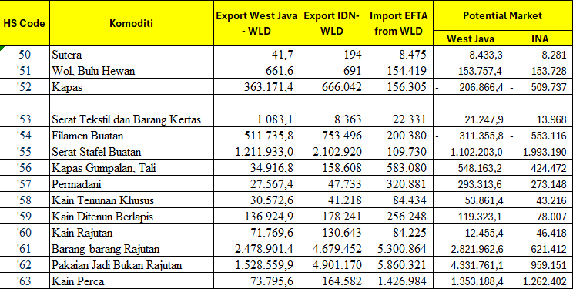

CONCLUSION
The study results show that the challenges of exporting textile products to EFTA countries are based on the regulation of textile export requirements, which are quite complicated. However, several supporting factors also exist, including competition from neighboring countries (Viet Nam) with a lower minimum wage than Indonesia. This is one of the crucial things in carrying out export activities. Vietnam can determine lower prices. Infrastructure, transportation access, and even tools and machines are not looked at by the government, making Indonesian textile products difficult to compete in in quantity and quality. Moreover, many business actors do not know about the existence of EFTA, especially the IE-CEPA agreement that has come into effect. Opportunity analysis was carried out by revealing comparative advantage, bilateral comparative advantage, and potential market analysis. The results of the revealed comparative advantage show that the five textile products with the highest competitiveness start from HS Code 55 (Artificial Stafel Fiber), HS Code 62 (Non-Knitted Apparel), HS Code 61 (Knitted Goods), HS Code 54 (Artificial Filament), HS Code 52 (Cotton). Meanwhile, Indonesian TPT products with the lowest competitiveness are occupied by HS Code 51 (Wool, Animal Hair), HS Code 50 (Silk), HS Code 53 (Textile Fibers and Paper Goods), HS Code 63 (Patchwork), HS Code 57 (Rugs). In addition to the RCA analysis of West Java TPT products, the author conducted a competitive analysis of West Java TPT products in the EFTA market. The five textile products with the highest competitiveness start from HS Code 62 (Non-Knitted Apparel), HS Code 61 (Knitted Goods), HS Code 55 (Artificial Stafel Fibers), HS Code 52 (Cotton), HS Code 63 (Patchwork). Meanwhile, West Java TPT products with the lowest competitiveness start from HS Code 51 (Wool, Animal Hair), HS Code 53 (Textile Fibers and Paper Goods), HS Code 58 (Special Woven Fabrics), HS Code 60 (Knitted Fabrics), and HS Code 57 (Rugs). The author also gets the market potential value for textile exports from West Java and Indonesia from the existing data. The study results show that the West Java market has the greatest potential in HS Code 62 (Non-Knitted Apparel), while the Indonesian textile market has the greatest potential in HS Code 63 (Patchwork Fabric). Therefore, it can be concluded that the results of the analysis show that West Java's textile exports have declined because the national textile industry has suffered a blow in the global market and the domestic market caused by a decline in world demand due to the global recession so that export demand fell by 40-50% throughout the first quarter of 2023. Complaints about imported textile products flooding the domestic market are dominated by imported goods, especially from China. Reforms from the Minister of Cooperatives and SMEs said that illegal imported used clothes control 31% of the domestic clothing market. The Indonesian Fiber and Filament Yarn Producers Association revealed that there are many irregularities in textile imports with various "modes," starting from the transfer of HS CODE, falsification of information of the origin of goods, to "under invoice," which is the value of the invoice is reduced to avoid paying taxes. Many unlicensed and unregistered import companies abuse import permits to smuggle imported goods.

BIBLIOGRAPHY
Akpansung, A. O. (2013). A Review Of Empirical Literature On Balance Of Payments As A Monetary Phenomenon. Journal Of Emerging Trends In Economics And Management Sciences, 4(2), 124–132. Https://Doi.Org/10.10520/Ejc135870
Alotaibi, A., & Mishra, A. V. (2014). Determinants Of International Financial Integration Of Gcc Markets (Pp. 749–771). Https://Researchdirect.Westernsydney.Edu.Au/Islandora/Object/Uws%3a19278/
Aminoto, V. T. P. S. Dan T. (2021). Ekspor Impor: Teori Dan Praktik Untuk Pemula. Cv. Mitra Cendekia Media.
Anggita Listianti, L. (2020). Analisis Daya Saing Dan Faktor-Faktor Yang Mempengaruhi Ekspor Produk Alas Kaki Indonesia Ke Amerika Serikat Perspektif Ekonomi Islam (Doctoral Dissertation, Uin Raden Intan Lampung)
Ardiyanti, D., & Alsa, A. (2015). Pelatihan “Plans” Untuk Meningkatkan Efikasi Diri Dalam Pengambilan Keputusan Karir. Gadjah Mada Journal Of Professional Psychology, 1(1).
Auboin, M., & Ruta, M. (2013). The Relationship Between Exchange Rates And International Trade: A Literature Review. World Trade Review, 12(3), 577–605.
Baltas, G., & Saridakis, C. (2013). An Empirical Investigation Of The Impact Of Behavioural And Psychographic Consumer Characteristics On Car Preferences: An Integrated Model Of Car Type Choice. Transportation Research Part A: Policy And Practice, 54, 92–110.
Beranda | Portal Kementerian Luar Negeri Republik Indonesia. (N.D.). Retrieved March 8, 2024, From Https://Kemlu.Go.Id/Portal/Id
Beranda—Kementerian Perdagangan Republik Indonesia. (N.D.). Retrieved March 8, 2024, From Https://Www.Kemendag.Go.Id/
Castellani, R. J., Rolston, R. K., & Smith, M. A. (2010). Alzheimer Disease. Disease-A-Month: Dm, 56(9), 484–546. Https://Doi.Org/10.1016/J.Disamonth.2010.06.001
Correlation Between Students’ Religiousness And Their Motivation In Learning: A Study At 2013 Level Of Elt Department Walisongo State Islamic University Semarang In The Academic Year Of 2014/2015—Walisongo Repository. (N.D.). Retrieved March 8, 2024, From Https://Eprints.Walisongo.Ac.Id/Id/Eprint/4567/
Dominick, Salvatore. (1997). Ekonomi Internasional, Alih Bahasa Oleh Haris Munandar (5th Ed.). Erlangga.
Fta Center. (N.D.). Retrieved March 8, 2024, From Https://Ftacenter.Kemendag.Go.Id/
Galina, C. S., Turnbull, F., & Noguez-Ortiz, A. (2016). Factors Affecting Technology Adoption In Small Community Farmers In Relation To Reproductive Events In Tropical Cattle Raised Under Dual Purpose Systems. Open Journal Of Veterinary Medicine, 06(01), 15–21. Https://Doi.Org/10.4236/Ojvm.2016.61003
Gnangnon, S. K. (2018). Multilateral Trade Liberalisation And Financial Openness. Economic Affairs, 38(3), 325–338. Https://Doi.Org/10.1111/Ecaf.12310
Gunawan, Y. (2021). Pertanggungjawaban Indonesia Dalam Pencemaran Asap Batas Lintas Negara. Lp3m Umy. Https://Scholar.Google.Com/Scholar?Cluster=12469513887399134406&Hl=En&Oi=Scholarr
Hardani, H., Andriani, H., Ustiawaty, J., & Utami, E. F. (2020). Metode Penelitian Kualitatif & Kuantitatif. Pustaka Ilmu. Https://Eprints.Itn.Ac.Id/13681/
Hidayat A, Lk Darusman Dan I Batubara. (2011). Fractination Of The Active Compound From Kepel (Stelechocarpus Burahol) Leaf Extract As Antibacterial. The 2nd International Symposium On Temulawak. Pusat Studi Biofarmaka Lppm Ipb. Bogor.
Hidayat, H., Astuti, R. S., & Puspitojati, E. Development Of The Marketing Strategy To Boost Wedang Sirih Rempah Product Market Share. Marketing, 1009, 9p.
Irwanto. (2006). Focused Group Discussion (Fgd): Sebuah Pengantar Praktis. Yayasan Pustaka Obor Indonesia.
Mahendra, I. G. Y., & Kesumajaya, I. W. W. (2015). Analisis Pengaruh Investasi, Inflasi, Kurs Dollar Amerika Serikat Dan Suku Bunga Kredit Terhadap Ekspor Indonesia Tahun 1992-2012. E-Jurnal Ekonomi Pembangunan Universitas Udayana, 4(5), 44541.
Manurung, J. J., Manurung, A. H., & Saragih, F. D. (2005). Ekonometrika: Teori Dan Aplikasi. Jakarta: Pt Elex Media Komputindo. Https://Scholar.Google.Com/Scholar?Cluster=16169641201681681750&Hl=En&Oi=Scholarr
Muritala, T., & Taiwo, A. (2011). Government Expenditure And Economic Development: Empirical Evidence From Nigeria. Mpra Paper, Article 37293. Https://Ideas.Repec.Org//P/Pra/Mprapa/37293.Html
Najmil, F. (2018). Perdagangan Rempah-Rempah Pada Cv.Rasdi & Co Kota Padang Tahun 1985-2016 [Diploma, Universitas Andalas]. Http://Scholar.Unand.Ac.Id/34642/
Octavia, E. R., & Wulandari, D. (2016). Analysis Of Effect Macro Variable On International Trade Of Indonesia. Business And Economic Research, 6(2), Article 2. Https://Doi.Org/10.5296/Ber.V6i2.10053
Okano-Heijmans, M., & Asano, T. (2018). Economic Diplomacy. In Routledge Handbook Of Japanese Foreign Policy (Pp. 251–266). Https://Doi.Org/10.4324/9781315643076
Pan, Q., Shikano, I., Hoover, K., Liu, T.-X., & Felton, G. W. (2019). Enterobacter Ludwigii, Isolated From The Gut Microbiota Of Helicoverpa Zea, Promotes Tomato Plant Growth And Yield Without Compromising Anti-Herbivore Defenses. Arthropod-Plant Interactions, 13(2), 271–278. Https://Doi.Org/10.1007/S11829-018-9634-9
Paryadi, D. (2020). Potensi Kerjasama Bilateral Indonesia Bangladesh Dalam Kerangka Preferential Trade Agreement. Cendekia Niaga, 4(2), 16–26. Https://Doi.Org/10.52391/Jcn.V4i2.510
Pasaribu, S., & Putri, A. (2021). Faktor Pendorong Indonesia Menandatangani Kerja Sama Indonesia European Free Trade Association-Comprehensive Economic Partnership Agreement (Ie-Cepa). Jurnal Ekonomi-Qu, 11(2), Article 2. Https://Doi.Org/10.35448/Jequ.V11i2.13234
Pencarian—Kbbi Vi Daring. (N.D.). Retrieved March 8, 2024, From Https://Kbbi.Kemdikbud.Go.Id/
Schumacher, R. (2013). Deconstructing The Theory Of Comparative Advantage. World Economic Review, 2013(2), 1–83.
Sugiyono. (2008). Metode Penelitian Pendidikan: (Pendekatan Kuantitatif, Kualitatif Dan R & D). Alfabeta.
Sukirno, Sadono. (2013). Makro Ekonomi, Teori Pengantar. Pt Raja Grafindo.
Suryanto, S., & Kurniati, P. S. (2022). Analisis Perdagangan Internasional Indonesia Dan Faktor-Faktor Yang Memengaruhinya. Intermestic: Journal Of International Studies, 7(1), 104. Https://Doi.Org/10.24198/Intermestic.V7n1.6
Syahputra, R., Robandi, I., & Ashari, M. (2015). Performance Improvement Of Radial Distribution Network With Distributed Generation Integration Using Extended Particle Swarm Optimization Algorithm. International Review Of Electrical Engineering (Iree), 10(2), 293–304.
Tambunan, T. (2000). The Performance Of Small Enterprises During Economic Crisis: Evidence From Indonesia. Journal Of Small Business Management, 38, 93–101.
Wang, H., Naghavi, M., Allen, C., Barber, R. M., Bhutta, Z. A., Carter, A., Casey, D. C., Charlson, F. J., Chen, A. Z., Coates, M. M., Coggeshall, M., Dandona, L., Dicker, D. J., Erskine, H. E., Ferrari, A. J., Fitzmaurice, C., Foreman, K., Forouzanfar, M. H., Fraser, M. S., … Murray, C. J. L. (2016). Global, Regional, And National Life Expectancy, All-Cause Mortality, And Cause-Specific Mortality For 249 Causes Of Death, 1980–2015: A Systematic Analysis For The Global Burden Of Disease Study 2015. The Lancet, 388(10053), 1459–1544. Https://Doi.Org/10.1016/S0140-6736(16)31012-1
Yogiswara, I. G. M., Lombok, L. L., Nur, A. I., Kumara, I. G. B. I., & Sutianti, N. N. S. P. (2022). Settlement Of Brand Rights Disputes Through The Commercial Court In Indonesia: Study Of Surabaya Court Decision. Indonesia Law Reform Journal, 2(3), 299–308.

