
Volume 3 Number 6 June 2024
E-ISSN: 2963-2900 | P-ISSN: 2964-9048
https://jmi.rivierapublishing.id/index.php/rp

Views of Bumi Siliwangi Dormitory Residents on the Need for the Use of Rainwater Reservoirs

Meta Nursyifa¹, Hani Sundari², Nazwah³, Syifa Dinda Trisetiyani⁴, Monica Safitri Ramadani⁵
^{1,2,3,4,5}Jurusan Pendidikan Teknik Bangunan, Fakultas Pendidikan Teknologi dan Kejuruan, Universitas Pendidikan Indonesia
Email: metanursyifa01@upi.edu, hani.sundari30@upi.edu, nazwah.03@upi.edu, ucanana13@upi.edu, monicasafitriramaadani@upi.edu

Abstract
The Bumi Siliwangi Dormitory is a facility provided by the University of Education Indonesia with a total of three buildings, including the women's dormitory building, the men's dormitory building, and the men's and women's runaway building. This study aims to examine the perception of dormitory residents towards the urgency of using rainwater reservoirs in the Bumi Siliwangi Dormitory, Universitas Pendidikan Indonesia (UPI), as well as to find out the number of clean water needs of dormitory residents, as an effort to overcome the problem of lack of clean water due to water pumps that are often damaged. This research method uses a descriptive method with a quantitative and qualitative approach. Primary and secondary data were collected from the Bumi Siliwangi Dormitory Building, with the research subjects in the form of dormitory residents and dormitory managers. The analysis of water needs is carried out based on urban water demand standards. The results of the study show that the dormitory water requirement is 18,352,200 liters/year, while the clean water capacity produced reaches 78,840,000 liters/year. Based on these results, it can be concluded that rainwater harvesting is not needed at this time.

Keywords: Bumi Siliwangi Dormitory, Rainwater Reservoir , Rainwater

Corresponding Author: Meta Nursyifa

E-mail: metanursyifa01@upi.edu

INTRODUCTION
Water is an essential necessity for all creatures on earth, especially humans. The presence of clean water is not only necessary to meet the basic daily needs of humans but also to support various other activities (Artiningrum et al., 2020). According to Artiningrum et al. (2020), Indonesia has significant rainfall, ranging from 2000-4000 mm per year. Despite its great potential, the use of rain as a source of water is a challenge in terms of the technology used (Marganingrum and Sudrajat 2018).
Rainwater harvesting is a method to stem rainwater that flows over building structures, roads, or fields during the rainy season (Pathak et al. 2024). The goal is to utilize the water for indoor and outdoor purposes (Silvia and Safriani 2018). The system operates to direct rainwater through the roof of a building into a canal, then collect it in a water tank, and drain it through pipes to a rainwater storage area. The excess water can then be drained into the infiltration well (Artiningrum et al., 2020).
Rainwater harvesting is the process of collecting rainwater that is collected on the roof of a building and then stored to further needs. The resulting water can be stored in surface reservoirs or in storage tanks (MAULINA 2023). The benefits of this system include providing additional water sources, reducing stormwater runoff, and supporting the recharge of groundwater accumulation (Ardana and Pamungkas 2016).
Based on the scope of its implementation, there are two categories in PAH: the first includes rainwater harvesting techniques through the use of building roofs, and the second through the use of storage as a means to collect rainwater that flows on surfaces such as ponds, canals, and similar construction structures (Yulistyorini 2011).
The difference between the two categories lies in the scope of their implementation. The first category focuses on individual scales, such as house buildings in a residential or urban area. The second category has a wider scale, generally related to rural areas in watersheds or subwatersheds (Harsono 2010).
The advantages of rainwater harvesting systems include: (1) Rainwater is the main source of all types of water, so rainwater harvesting must be a priority in providing water supply. (2) Decentralized management reduces costs and energy and increases flexibility and security in water management. (3) Rainwater harvesting has a multi-function, not only to collect and reuse rainwater but also to reduce overflow water and help groundwater replenishment.
In level II areas, the roofs of houses and office roofs can be used for rainwater collection areas. The potential for rainwater harvesting can be calculated with a simple formula that takes into account the amount of water that will be produced by a particular rain in an area. However, losses due to evaporation or absorption from the tank surface must also be taken into account. For example, when calculating the roof of a house, you can consider how much the roof area, flow coefficient, and also the amount of annual rainfall. The result of this calculation is usually determined by the capacity of rainwater in liters (L) (Meliana, 2023).
Universitas Pendidikan Indonesia provides dormitory facilities for students. The strategic location and proximity to the campus are special attractions for dormitory residents because it does not take much time to get to campus. The rental price given per three months is IDR 1,650,000.00 with a capacity of two to three people in each room. The rent provided is relatively affordable when compared to the rental price in the environment around the campus. In addition to adequate housing facilities, students living in the dormitory receive direction to improve their academic, leadership, and moral abilities (Ditmawa Universitas Pendidikan Indonesia n.d.).
According to the assessment Green Metric UI for the Green Campus ranking, Universitas Pendidikan Indonesia currently occupies the 44th position in Indonesia, 100th in Asia, and is equivalent to the 500th ranking globally (Devitama, Paramita, and Ardiani 2020). With this data, Universitas Pendidikan Indonesia should have friendly and environmentally friendly facilities and infrastructure to support its student activities. One of the campus's efforts to meet Eco Campus with the implementation of a rainwater harvesting system in the student dormitory of the University of Education Indonesia.
In the dormitory environment, there are challenges that must be faced, including damage to water pumps that often occur and the imbalance between the clean water provided by the dormitory and the water needs of the dormitory residents. It is important to note that the dormitory is located in the campus area, so any disruption to the clean water supply system that requires repairs by the campus also has an impact on the comfort of dormitory residents. Taking into account the situation that occurs, so that to overcome the problem of clean water shortage requires an influential and competent approach. One of the steps that can be taken is to implement a rainwater harvesting system. The expected results of this study are that the urgency of rainwater harvesting that utilizes the roof of the building as a source of clean water for dormitory residents can be known.
METHOD
In order to achieve the objectives of this research, a descriptive method with a quantitative and qualitative approach is used. The quantitative method was obtained from data collection, analysis, and discussion, as well as conclusions and proposals according to the formulation of the problems presented. Meanwhile, qualitative methods can be obtained after conducting interviews. The object of the research used is the Bumi Siliwangi Dormitory Building located on Jl, with dormitory residents as subjects in the research. In the research conducted, the data collection method includes the use of primary data and secondary data. The primary data obtained is in the form of the number of rooms, the number of occupants, and the occupant capacity of each room. Secondary data obtained is in the form of documentation of water storage tanks and water management installations. The data analysis is carried out by calculating water needs and the amount of clean water that the dormitory is able to produce.
For people in level II areas, 120 liters/person/day of clean water is needed, while for residents in rural areas, 60 liters/person/day of clean water is needed (Suheri et al. 2019). Once the type of area to be inspected is determined, it can be calculated (BSN 2002).
Because this research was carried out at the Bumi Siliwangi Dormitory, the formula used in this case is to calculate urban water needs:
QDS=ΣPd x 365 days x 120liters/person/day
Known:
QDS=Water demand in urban areas (liters/year)
ΣPd=Total number of dormitory residents

RESULTS AND DISCUSSION
- State of Study Area
The Bumi Siliwangi Dormitory is a facility provided by UPI with a total of three buildings, including the women's dormitory building, the men's dormitory building, and the men's and women's runaway. The area of each building is 3213 m2, with the number of water reservoirs (toren) in each building being as many as four. The capacity of each reservoir is 3000 liters, and in each building, there is one recible well. The available clean water is obtained from reciprocating wells using water pump radar so that the water is automatically pumped up to fill the town. After reading several relevant articles, it was found that previous research was generally conducted in areas that were already equipped with rainwater reservoirs. Therefore, this study observes areas that do not yet have rainwater reservoirs by applying the same theory.

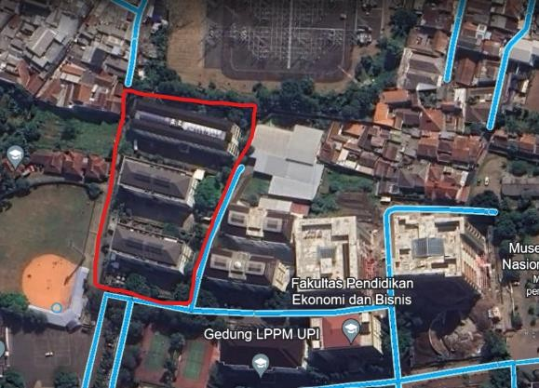
Figure 1. Location of Bumi Siliwangi Dormitory

- Water Needs Analysis
In this study, the analysis of the water needs used includes internal needs data for the Bumi Siliwangi Dormitory using data on dormitory residents in March 2024 and the number of water needs used. The data on residents of the Bumi Siliwangi Dormitory in March 2024 is 150 residents of the women's dormitory, 98 residents of the boys' dormitory, 125 residents of the women's dormitory, and 46 residents of the boys' dormitory, with a total of 419 residents.
In accordance with BSN (2002), analysis and calculation of water needs can be described by the following calculations:
QDS=Σresidents of the Bumi Siliwangi Dormitory in 2024 x 365 days x 120 liters/person/day
= 419 people x 365 days x 120 liters/person/day
= 18,352,200 liters/year
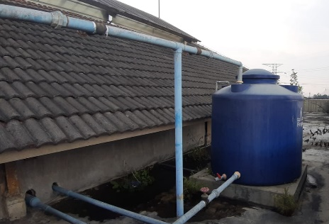
Figure 2. Water Storage Toren

- Calculation of the Amount of Clean Water That Can Be Produced
The amount of clean water that the dormitory can produce per year is as follows: there are four tokens per building, so the total tokens owned are 12 tokens. Each token is recharged five times per day, so the total recharge is 60 times. With a capacity of 3000 liters per ton, the total water capacity per day is 36,000 liters. The amount of water produced is multiplied by the amount of refill so that the total water produced per day is 216,000 liters. If calculated per year, the amount of water produced is 216,000 liters multiplied by 365 days, so the total clean water that the dormitory is able to produce per year is 78,840,000 liters.

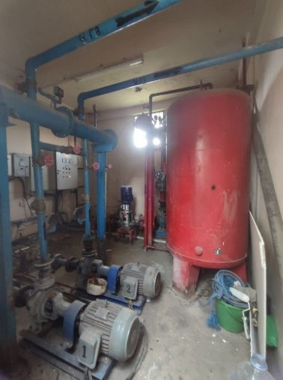
Figure 3. Water Management Installation

So, based on calculations, the Bumi Siliwangi dormitory requires clean water of around 18,352,200 liters/year. By looking at the condition of the clean water management infrastructure in the dormitory, it is able to produce 78,840,000 liters/year of water. Based on the results of interviews with 30 dormitory residents, it was obtained that the clean water provided was able to meet the needs of dormitory residents, while the obstacles that often occurred came from damaged water pumps that affected the capacity of water that could be provided. However, the follow-up process from the dormitory management was quite responsive, so the dormitory residents did not have to wait too long.
The dormitory itself does not have a rainwater reservoir because the dormitory feels that it is not needed. However, if in the future there is a surge in the number of dormitory residents and the water source produced is insufficient, the dormitory will consider installing a rainwater collection tank with the note that the installation of the installation is not difficult, able to support dormitory infrastructure and the necessary funds are affordable.

CONCLUSION
From the results of the calculations, the water needed is 18,352,200 liters/year while the amount of clean water that can be produced by the dormitory is 788,400,000 liters/year. From the results of the calculation, it was concluded that rainwater harvesting was not needed to be made in the Bumi Siliwangi dormitory because the need for clean water had been met. The suggestions that can be given regarding the next research are to collect historical data on rainfall at the dormitory location and calculate the potential for rainwater collection that can be harvested if you want to use a rainwater reservoir.

BIBLIOGRAPHY
Ardana, Putu Doddy Heka, and Tri Hayatining Pamungkas. 2016. “Teknologi Pemanenan Air Hujan Di Perkotaan, Suatu Pengantar.” Jurnal Teknik Gradien 8(1): 93–104.
Artiningrum, Tati et al. 2020. “Potensi Pemanenan Air Hujan Sebagai Upaya Pemenuhan Air Baku Bagi Warga Desa (Studi Kasus: Desa Cikalong, Kabupaten Bandung Barat).” Geoplanart 3(1): 57–68.
BSN. 2002. “Standar Nasional Indonesia No. 19-6728.1-2002 Penyusunan Neraca Sumber Daya - Bagian 1: Sumber Daya Air Spasial.” Badan Standardisasi Nasional (BSN) ICS 13.060: 10.
Devitama, F. F., B. Paramita, and N. A. Ardiani. 2020. “Planning and Designing UPI Science and Techno Park as a Green Campus Center in Universitas Pendidikan Indonesia.” IOP Conference Series: Earth and Environmental Science 520(1).
Ditmawa Universitas Pendidikan Indonesia. “Asrama.”
Harsono, Budi. 2010. “TEKNIK PEMANENAN AIR HUJAN (RAIN WATER HARVESTING) SEBAGAI ALTERNATIF UPAYA PENYELAMATAN SUMBERDAYA AIR DI WILAYAH DKI JAKARTA.” jurnal sains dan teknologi modifikasi cuaca.
Marganingrum, Dyah, and Yayat Sudrajat. 2018. “Estimasi Daya Dukung Sumber Daya Air Di Pulau Kecil (Studi Kasus Pulau Pari).” Jurnal Wilayah dan Lingkungan 6(3): 164–82.
MAULINA, ANANDHA. 2023. “STUDI PEMANFAATAN AIR HUJAN SEBAGAI SUMBER AIR BAKU UNTUK AIR BERSIH PADA KAMPUS UNIVERSITAS BOSOWA MAKASSAR.”
Meliana, Litany. 2023. “Pemanenan Air Hujan (PAH) Sebagai Alternatif Sumber Air Untuk Masyarakat Perkotaan.” Pembangunan Berketahanan Iklim.
Pathak, Shray, Shreya Sharma, Abhishek Banerjee, and Sanjeev Kumar. 2024. “A Methodology to Assess and Evaluate Sites with High Potential for Stormwater Harvesting in Dehradun, India.” Big Data Research 35: 100415.
Silvia, Cut Suciatina, and Meylis Safriani. 2018. “Analisis Potensi Pemanenan Air Hujan Dengan Teknik Rainwater Harvesting Untuk Kebutuhan Domestik.” Jurnal Teknik Sipil dan Teknologi Konstruksi 4(1).
Suheri, Asep, Cecep Kusmana, Moh Yanuar J Purwanto, and Yudi Setiawan. 2019. “Model Prediksi Kebutuhan Air Bersih Berdasarkan Jumlah Penduduk Di Kawasan Perkotaan Sentul City.” Jurnal Teknik Sipil dan Lingkungan 4(3): 207–18.
Yulistyorini, Anie. 2011. “Pemanfaatan Air Hujan Sebagai Alternatif Pengelolaan Sumberdaya Air Di Perkotaan.” Teknologi dan Kejuruan 34(1): 105–14.

